**Start**

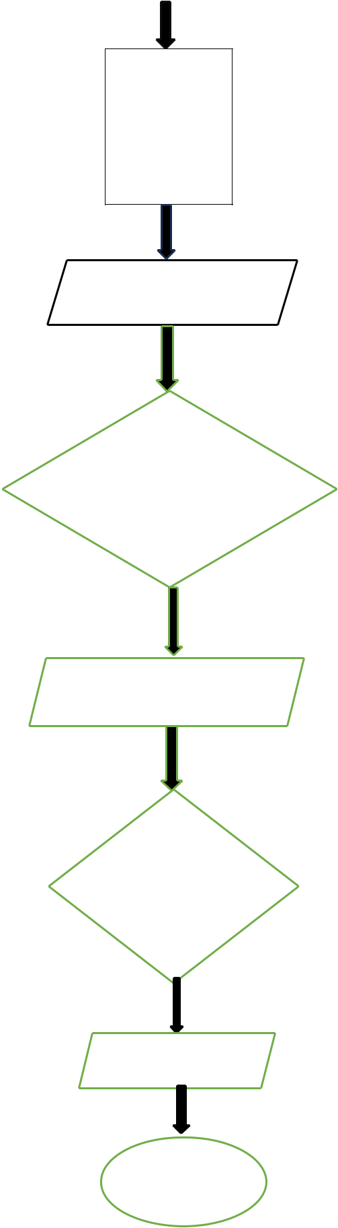

**yn= “N”**

**next=0**

**large=0**

**Input next**

**Y If**

**Next > large**

**Iarge = next**

**Input yx**

**If N**

**Yx > “N”**

**Print large**

**STOP**